COVID-19 is a respiratory disease caused by a new coronavirus
What Is COVID-19?
first discovered in 2019. The name COVID-19 is short for
“Coronavirus Disease 2019”1,2.
It is without question that the health and well-being of our Vietnam-Era Registries members are at the forefront of our minds. Now, more than ever, we must be vigilant in safeguarding the well-being of our loved ones and ourselves. The COVID-19 pandemic has increased anxiety and stressors
globally, making it important to consider mental health and stress reduction during this time. We’ve
compiled some resources and information for our Registry members that may be helpful. Two
common mental health conditions to consider include:
 | Post-Traumatic Stress Disorder (PTSD) |  | Depression
 | PTSD symptoms include intrusive memories, dissociation, feeling numb or guilty, and hypervigilance³. A free and anonymous PTSD screening is available online at:  www.myhealth.va.gov/mhv-portal-web/ptsd-  screening  There are effective treatments for PTSD.  According to the VA National Center for PTSD,  53% of Veterans who take part in common treatments for PTSD no longer experience  symptoms. Those common treatments include cognitive processing therapy, prolonged  exposure therapy and eye movement  desensitization and reprocessing (EMDR)⁵. |  | Depression symptoms include changes in sleep and appetite, loss of energy and  interest, and feelings of hopelessness⁴. A free and anonymous depression screening is available online at: www.myhealth.va.gov/  mhv-portal-web/depression-screening The VA can work with Veterans to set up technology that allows virtual video  appointments using cell phones, tablets, and computers. Video therapy sessions have been found to be as effective as in-person therapy sessions for treating depression in Veterans  58 and older⁶.

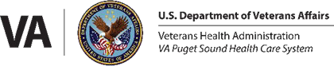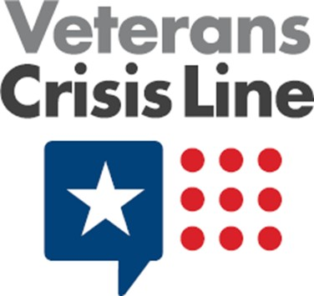Call
For more certified information about COVID-19, visit:
www.coronavirus.gov
www.va.gov/coronavirus-veteran-frequently-asked-questions/
www.cdc.gov/coronavirus/2019-ncov/index.html

1-800-273-8255
and Press 1

Visit Online
www.VeteransCrisisLine.net

Text
Send Messages to

838255

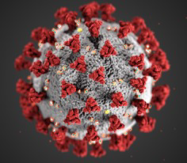
VIETNAM-ERA REGISTRIES
Health & Well-Being during COVID-19

The COVID-19 pandemic response has caused mental health and financial stress for many individuals and families. Listed below are some resources and tools that may help with overcoming the obstacles many people are facing.

Financial |  | Mental Health Resources
Resources
Federal COVID-19 Resources
www.benefits.gov/help/faq/
Coronavirus-resources
Mental Health during the COVID-19 Outbreak
A site that provides a list of strategies for developing and maintaining peace of mind during the COVID-19
outbreak:
www.mentalhealth.va.gov/coronavirus/
Housing Assistance  www.hud.gov/coronavirus  Social Security and Medicare Resources  www.ssa.gov/coronavirus/ &  www.medicare.gov/medicare-  coronavirus  For additional information on  Veteran-Focused Financial Resources  www.consumerfinance.gov/  coronavirus/servicemembers/ |  | COVID Coach  COVID Coach is a VA-developed mobile app for managing stress and mood, and accessing additional resources. It’s available to download for free in the app store (iTunes for iOS and Google Play for Android devices). For more  information visit:  www.ptsd.va.gov/appvid/mobile/COVID_coach_app.asp  Make the Connection  An online resource designed to connect Veterans, and their family members and friends, with information,  resources, and solutions to issues affecting Veterans’ lives:  Coaching into Care  A site for Veterans’ family and loved ones to learn from licensed psychologists and social workers how to better support a Veteran they care about, free-of-charge:  888-823-7458  www.mirecc.va.gov/coaching/index.asp  MiltaryOneSource  A source for non-medical counseling for military servicemembers and their families:  1-800-342-9647  www.militaryonesource.mil/confidential-help/non-  medical-counseling
References:
1:https://www.who.int/emergencies/ diseases/novel-coronavirus-2019/technical- guidance/naming-the-coronavirus-disease- (covid-2019)-and-the-virus-that-causes-it
2:https://www.cdc.gov/coronavirus/2019- ncov/symptoms-testing/symptoms.html
3:https://www.nami.org/NAMI/media/NAMI
-Media/Images/FactSheets/PTSD-FS.pdf 4:https://www.nami.org/About-Mental- Illness/Mental-Health-Conditions/
Depression
5:https://www.research.va.gov/topics/ ptsd.cfm#research1
6:https://www.research.va.gov/topics/
depression.cfm

THANK YOU FOR YOUR SERVICE

